Nitish Neelagiri

[Company name] | [Company address]

USER PERSONA REPORT

TEam 18

|  |  |
| --- | --- |
| AGE | 65 |
| OCCUPATION | Theater Actor |
| MARITAL STATUS | Widow |

**FOCUSED STRONG KIND**

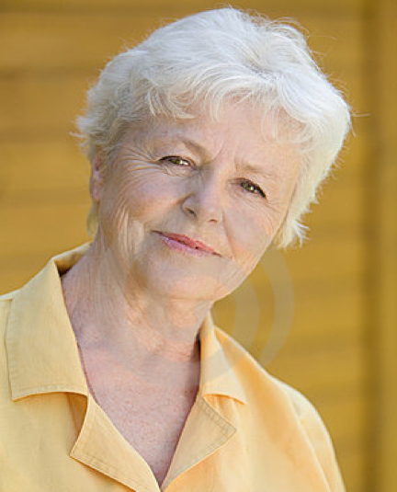

“If I had a way to browse through the website without any confusion, it would make my job of booking an appointment much easier.”

EXPECTATIONS

* Discounts and deals on dental packages
* Easier websites to book an appointment
* Visible graphics and large content areas
* Friendly greetings on her homepage
* Live chat option with a medical representative

FRUSTRATIONS

* Few unreliable websites crash in the middle of booking appointments
* Medical expenses that are skyrocketing

PERSONAL INTERESTS

* Enjoys volunteering activities such as teaching and serving the poor
* Radio jockeying

BIO

Ruth runs her house with the pension she gets from the government and salary from her theater. With no children to take care of her, she has to do her chores herself. With only a basic knowledge of websites and internet, she manages to book her appointments with the doctor. She has lost her strength in eyesight over the years and could, now, only see huge blocks of letters on a computer screen. Thus it is very important for her to find visible content on the website. And also, discounts and packages on dental fee could really attract her to the website.